CCCM Cluster Somalia Minimum Standard - Complaints Feedback Mechanism

The objective of this document is to outline the basic feedback infrastructure that partners have agreed to implement in IDP sites. Under these minimum standards, partners will administer complaints feedback mechanisms that adhere to either hotline, or face-to-face CFM systems. Additionally, the document provides guidance and tips that partners can utilize to assure that CFM systems are well trusted and well perceived by IDP communities, and that they are accessible to all populations in sites.
Complaint- A statement that a situation is unsatisfactory or unacceptable. For example, expressing opinion issue or concern with NGO services in a particular location.

Feedback- An action taken as a result of receiving a complaint and the response on what actions have been taken to address their complaint/ issue / concern

Mechanism- A system in place to record all information, a way to keep track of all the complaints. Having a system to be able record and analyze information received to be able to use as an evidence bas to inform programming.
The CCCM cluster requests partners to utilize a CFM method that best suits members of the IDP community; whether this be a hotline, CFM desk, mobile teams or a combination of these models. Furthermore, the cluster is in the midst of establishing an agreed, standard intake form and database for partner use. The objective is for all partners to capture the same data categories or data points that can be further analyzed and broadcasted for advocacy work. Additionally, these documents are fully aligned with the Community Engagement Working Group’s common feedback approach and will eventually feed into the feedback data captured by other service providers throughout Somalia.
What is a Complaint Feedback Mechanism?
Complaint/ issue tracking is an important source of compelling evidence that informs decisions and programme implementation. Tracking and analyzing trends in complaints provides important evidence and knowledge of the key concerns that affected populations face.

We must be clear to all staff and affected population/communities on the scope and remit of the CFM system. There are issues that are outside the scope of what CCCM partner action can do. For example, disputes with neighbors.
Why is CFM Important?
- Recognition of the dignity and rights of affected population, including the right of people to express their opinions and concerns.
- Holding organizations to account against the promises and commitments made to the communities they support and other stakeholders.
- Improved impact and effectiveness of programmes. When there is an operational and effective CFM system for recording and analyzing trends, CFM data can provide evidence-driven data to improve programming e.g. through early identification and management of issues and risks; protection of staff by providing them with a way to investigate and respond to issues; continuous learning and improvement
- Strengthen relationship between service providers/ organisations and affected populations/ community. The communities / affected populations better understand the services that are available and are able to hold organizations to account for commitments made. With effective response and feedback, a subsequent development of trust and engagement occurs which ultimately contributes to more effective programming.
Standard Operating Procedures for CFM
Establishing Complaints Mechanisms
- Prior to establishing a complaints feedback mechanism at site-level, there is a pertinent need to obtain comprehensive information from the site-level about how populations would prefer to raise complaints. Furthermore, special measures should be put in place to allow people with special needs (PwSNs) and other populations that are unable to access mobile phones or are unable to access CFM desks.
- Hold community meetings with site populations about the intention of the CCCM partner to establish a CFM within a particular site. During such sessions, CCCM partners should share ideas that they have for the mechanism and focus on receiving feedback and opinions about how CCCM partners can better tailor and design their system around the preferences of community members.
- Gather information from the community (particular focus on traditionally marginalized groups) about what hours and days members of the community would prefer to contact hotline services or access desks. In addition, gather information about how individuals would like to receive feedback on complaints (mobile phone, shelter-level meeting or meeting in CFM office).
- Make sure CFM desk locations are agreed in consultation with the community and that desks, when possible, are located inside private rooms within community center. When possible, these private rooms will have a separate entrance to promote enhanced confidentiality. This design has been mainstreamed within the CCCM clusters community center design.
- Engage internally as a CCCM team about what type of CFM support is realistic. For example, there is a need to have robust discussions about what staff members can be focal points for the CFM desk/hotline system, can this operation be outsourced to highly competent and trained community mobilizers, what is a realistic expectation?
- Each organization is to assign two staff members that will serve as focal points for the agency’s CCCM CFM system. These two individuals will receive updates on Kobo form and intake form alterations as the CFM system continues to evolve.
Complaints Feedback Mechanism Methodology
- CCCM partners are to operate through two CFM focal points. These individuals will be trained on how to record complaints and provide information request response, in addition to referral pathways and specialized trainings from GBV partners on sensitive case referrals. These individuals will record complaints using the standardized intake form which is provided by the CCCM cluster. Once this form is complete, it can either be photocopied for referral purposes to service providers or file safely within an agency’s office. When possible, it is best to have at least one of the CFM focal points be a female staff member to encourage participation from female beneficiaries. When setting up a CFM desk for a day, it is important that half of the day is located at a fixed desk, with the other half of the day desk operators are mobile inside of the site. This will allow the focal point to deliver complaints information to individuals who have recently filed complaints, as well as allowing for access to individuals who may not be able to reach the fixed desk. Lastly, this person should be wearing designated CFM visibility which also displays the logo of the CCCM partner. This CFM logo should be circulated with the community so that they are able to associate that logo with the CCCM partners CFM system.
- Once a complaint has been filed, this data should be compiled using an intake form with informed consent being obtained from the individual making the complaint. The CFM focal point and/or other members of staff should now work on contacting service providers according to the complaints that have been registered. An inter-agency referral form/or copy of intake form/detailed email with necessary data should be filled out for each complaint and sent via email to the partner focal point with follow up done via mobile (when partners have not responded to emails within three business days). Partners should be complicit and willing to participate in CFM systems with a universal understanding that CFM systems are not mechanisms to police organizations, but are established to assist in identifying some gaps. CCCM CFM staff should obtain a response from the service provider about how they are going to rectify a raised complaint within 14 days.
- Information related to how a service provider is going to remedy a complaint will be provided to the individual who has made a complaint based on how they’d like to best receive feedback. When submitting a complaint, individuals have the option of stating how they want to be informed by the CCCM partner on the overall response to the complaint (mobile phone or home visit).
- Once a service provider has fully addressed a specific complaint, details regarding the action should be provided to the community member who originally raised the said complaint. If satisfied with the outcome, the case will be changed from pending to close. Once this has been done, the CFM staff member will upload the complaints data using the cluster’s standard kobo form. CFM data will be linked directly to the CCCM cluster via the use of a central CFM database/ODK account. This data will be displayed using power bi on a separate CCCM website which will allow for stakeholders to disaggregate data and information related to particular sectors, geographic location and demographic making complaints. This data will also be showcased within the CFM database that is created through the kobo data that has been submitted. Partners are to upload complaints data using the cluster provided Kobo form for all cases that are closed, or cases that have been open for more than 14 days. Partners will have the ability of accessing their uploaded complaints data via Kobo and will have the ability to alter the status of a complaint in addition to the satisfaction of the complaintee. Partners that wish to upload cases that have been opened for less than 14 days are permitted to do so as long as they are manually adjusting the complaint status once a case has been deemed closed.
- CCCM partners are encouraged to submit monthly CFM snapshots displaying the main complaints recorded during the month with trends that are facing specific geographical regions based on past reports. This data will be circulated with the sub-national/national cluster in addition to service providers operating within a particular area.

Agency and staff roles and responsibilities
CCCM Partner staff or designated CFM Focal Points:
- Follow up with complaints/ investigate issues with service providers at site/district-levels when relevant
- Maintain up- to date contact information for service providers and referral maps at the site/district-levels
- Deliver trainings to community groups, community awareness & information campaigns about the CFM system
- Be updated with site-level or area-based activities so that individuals requesting information about service provision can be assisted on the spot instead of having a complaint registered.
- Provide confidential feedback to community and individuals about complaints that have been filed
- Daily camp walk-a-rounds during days in which a feedback desk is established with emphasis on visiting shelters of people with special needs (PwSNs)
CMC Members
- Assist CCCM partners in relaying awareness and information campaigns related to the CFM desk/hotline assistant or related to issues/information requests that are being regularly picked up via the CFM desk/hotline
- To be trained on the functionality of the CFM and to retrieve information which may be beneficial for CFM desk/hotline workers (what are some of the top information requests, what populations are not able to access the CFM system, what times would the community prefer systems to be available during)
- Provide recommendation and guidance to CCCM partners on ways to enrich and improve CFM system at the site-level
CCCM Partner TL/PM
- Maintain up- to date contact information and referral maps either for the site-level, or if more applicable, for the area that a CCCM partner is covering with CFM activities
- Provide inter-agency workshop on the CFM system that a partner is attempting to establish, sensitizing partners on the CFM process and the role that they are to play within the system. This is something that should be done in joint collaboration with the sub-national cluster coordinator.
- Provide regular CFM trainings and updates to partner staff members and members of the community including but not limited to the CMC
- Creation and circulation of CFM snapshot document which is to be created monthly with key trends and analysis highlighted. This document (see annex 1) should be sent monthly to partners and circulated with CCCM cluster focal points

Key Protection mainstreaming principles for CFM:

- Informed consent
The person must know how, why and with whom we will share this information. If someone does not consent to partners sharing their information we CANNOT share! Informed consent questions will be added to the standard CCCM intake form with two informed consent questions asked during every filed complaint or information request.
- Confidentiality
It’s important that we don’t talk about sensitive issues freely in the site, only the focal points or partner contacts that are acting upon a complaint need to know – i.e CFM desk/hotline operator (assuming this individual is tasked with making referrals as well).
- Protect people’s privacy, dignity
Only take/ share information, with informed consent and only the details you need to take action/ refer the case. For example, if there is a complaint about someone needing further medical assistance that the clinic has not been able to provide, we are NOT medical professionals so we do not need all the medical details of the cases..
Recording complaints / issues
Complaints are to be recorded through the CFM desk/hotline operators paper intake form. CFM focal points should record complaints during daily desk hours, hotline hours or camp-walk –a-rounds.
Referral & Response
CFM focal points refer cases as necessary to relevant service providers at both the site-level when possible and at the regional level. However, many issues are not solvable within a short period, such as shelter/NFI needs. For those types of issues/ complaints it is important that the issues are tracked and monitored over time. The number of complaints received will be shared with relevant agencies to inform future programming.
This is most commonly done through the CFM monthly snapshot or the sector’s CFM dashboard which is shared with service providers help inform agencies of the types of complaints we receive and provide evidence-driven data to inform programming. However, it is important that affect populations/ communities are aware that their complaint is important and the issue will get shared with relevant agencies but that it might not lead to an immediate result but part of long term advocacy.
CFM focal points, with support from the CCCM agency TL/PM will speak to relevant service providers at the regional level about established appropriate referral pathways. See referral pathway documents.
GBV cases:
- ALL CFM staff have a responsibility to be extra mindful, respectful and sensitive when listening to GBV issues. These cases are especially sensitive and it is important that a private room is available to talk discreetly in addition to ensuring that the survivors are listened to and supported.
- Confidentiality and informed consent are especially important. DO NOT take notes or record any identifying information. These cases are sensitive with any notes or information gathered about a case presenting a risk to the survivor. Be respectful of a survivors privacy and do not talk about the issue to other staff in the office. Privacy and confidentiality are important to ensure the safety and wellbeing of the survivor.
- Provide referral to specific GBV/protection services available in the site or district. This should include an immediate call to the GBV referral focal point that is working in the area. If a GBV partner is not present in the site, a regional-level GBV focal point should be established in close consultation with that partner. Ensure that referral contacts are updated regularly and that partners are able to respond immediately to cases.
Referral
It is important to explain to the survivor that confidentially; privacy and consent are very important and that our primary concern is how we can support them. As CCCM partners, we do not provide services / support for GBV survivors directly. Instead, we offer referrals in the most confidential way possible without sharing any identifying information.
CFM focal points are responsible for sharing information on services available in the site and providing the following options:
- CFM Focal Point offers to accompany the survivor to designated GBV services in the site or region
- If the survivor is nervous about going to the GBV centres, CFM focal points can facilitate a meeting at the CCCM community center in the centers private room.

GBV cases should be managed by trained GBV staff/ teams, as CCCM / CFM staff there is no follow up or feedback to be provided as doing more could put the survivor at risk. However, with informed consent of the survivor the case should be entered into the CFM database without any Identifying information.
Recording GBV Complaints on ODK
At no point should any identifying information, name shelter number be noted down or recorded in ODK however with informed consent from the survivor we should record in ODK without identifying information as follows:
Enter the complaint on the ODK with site name but WITHOUT shelter and unit number. In the name section enter “GBV”, for issue type select ‘ protection’.

The Database
Partners will feed into a centralized database operated by the CCCM cluster UNHCR/IOM with partners only having access to data that their respective organizations have submitted. This database (Kobo sheet) will be managed by the CCCM cluster with information products such as a real-time Power BI dashboard created displaying complaints data for all of Somalia. This dashboard will allow for various sector partners and stakeholders to note trends and specific gaps that may require further sectoral support.
Closing the Feedback Loop
- A Complaint Response Mechanism is effective if, at a minimum, it supports the collection acknowledgement, analysis and response to feedback, thus closing the feedback loop. Without closing the feedback loop

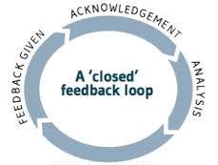
First, for effective CFM systems to be functional, it is fundamental that the community understand the purpose and objective of a CFM. As a result, persistent awareness sessions and information sharing activities must occur to assure that members of the community are aware of the CFM system and how to access it.
It is important to set expectation with IDPs on how the CCCM partner is able to provide feedback. Although it would be ideal to response to every individual complaint directly this is not always possible. Therefore, we may conduct wider community messaging about issues that have received numerous identical complaints (ie. When will the UCT occur this month?). This is also an important way for CCCM partners to share messaging within the community so that all members of the community can be aware of key activities enhancing knowledge of what is occurring within the site.
Methods of feedback:
- Camp Coordination Meetings
- Door to door visits when possible/ if necessary during CFM Focal Point camp walk- a-round
- Speaking with CFM focal points during daily desk hours
- Phone calls to members of the community
- CCCM Outreach activities such as information campaigns (loud speaker or shelter-level announcements)
- Notice board messaging or utilizing information boards within the site
- Having CMC members support with key messaging related to the CFM system
- Members of the community volunteer to support in spreading messages in their area of the site

CFM team methods of CwC:
- Direct shelter visits to provide feedback to PwSN and PwD
- Loud speaker or door to door messaging
- Camp walk –a-round providing messaging on CFM and the importance of raising / tracking complaints
- Awareness raising meetings with community groups
- Awareness raising meetings with service providers
- Creation of CFM videos in Somali
- Banners at distributions and in community centres
- Awareness raising campaigns on specific issues where many complaints have been received

Annex 1.
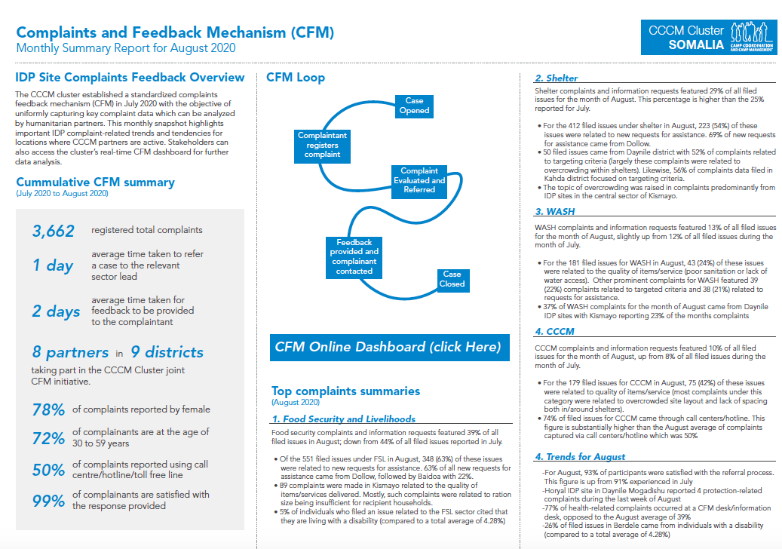
September 2020

